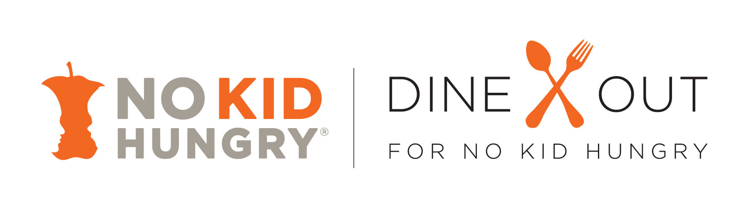

Creating Your Own Marketing Materials

How To Use These Guidelines:
To help you develop your own co-branded Dine Out For No Kid Hungry marketing materials, we’ve prepared the following guidelines. It is critical that you send proofs of your creative materials to us for review and approval before you produce them. Please allow at least 3 working days. Contact and send the proofs to your Dine Out For No Kid Hungry account manager.

All of your Dine Out For No Kid Hungry materials should clearly communicate the following:
- The program: No Kid Hungry®
- The logos: yours and No Kid Hungry’s (not the Dine Out For No Kid Hungry logo).
- The cause: to end childhood hunger in America and/or to help ensure every child gets the nutritious food they need, every day.
- Actions you are taking to support the program and its cause: your promotion and its dates.
- Additional actions customers can take to be part of the solution:
  - Learn more and donate at NoKidHungry.org.
  - Share their No Kid Hungry experiences—including dining with you--in pictures and words via social media: Twitter and Instagram (@NoKidHungry) and Facebook
  - Dine out, often.

Content:
Please use the following messaging as guidelines for your promotional content.
- Dine out at [COMPANY] during [MONTH] [OR MORE SPECIFIC DATES if applicable] and make No Kid Hungry® a reality.
- Dine with us this [MONTH] [OR MORE SPECIFIC DATES if applicable] to help end childhood hunger in America. The more often you dine out, the more money we raise, and the more meals we help connect with kids who need them.
- [COMPANY NAME] will [YOUR OFFER] this [MONTH] [OR MORE SPECIFIC DATES if applicable]. Help us make sure every child in America gets the healthy food they need, every day.
- Dine out with us this [MONTH] [OR MORE SPECIFIC DATES] and help end childhood hunger in America.
- Learn more about how you can help end childhood hunger in America at NoKidHungry.org.

Design:
All materials must follow No Kid Hungry’s Brand Usage and Logo Usage Guidelines, below, and include:
- Full No Kid Hungry logo, in (see color breakdowns below), black or reversed out to white (no other colors), with registration mark in place.
- Your logo
- No other logos or marks should be used.
All logos and a copy of the complete No Kid Hungry Brand Guidelines can be downloaded from the online resource center.

Approvals:
No Kid Hungry must approve the copy and design of all materials at least three working days before final production. This includes point-of-sale collateral and packaging, press releases, advertisements and public service announcements, promotional emails, posters, banners, flyers and any other patron or consumer communications. Content must adhere to the Better Business Bureau’s Cause Marketing Guidelines (available on the resource center), which stipulates full disclosure to the consumer on all packaging, advertising and promotional materials in clear, unambiguous terms. Send all materials to your account manager for approval.

No Kid Hungry® Logo Usage Guidelines
Please follow these guidelines when using the No Kid Hungry logo. Similar guidelines for using the brand name in text appear after the Logo Usage Guidelines below.

The full integrity of No Kid Hungry’s logo must be maintained, i.e. the campaign brand name (No Kid Hungry), and apple core must all remain intact. Do not modify the apple core/faces or borders, overlay or introduce new images, drop-shadows, rule lines or other graphic elements into the logo.

Recommended Logo Usage:
Horizontal and in color.

The No Kid Hungry orange color breakdown is as follows:
- PMS 166C/1665U
- C0 M74 Y100 K0
- RGB 242/103/34

The logo can also be turned black, gray or orange against a light background or reversed out white on a dark background. Any other color usage is not permitted.

The logo must be unobstructed by other elements in the layout, and should be surrounded with a reasonable amount of white space. Minimum recommended size is 1 inch wide.

No Kid Hungry® Brand Usage Guidelines

Please follow these guidelines when using the No Kid Hungry brand name in text.

Correct first usage:
All brand names must appear in full the first time they are used in body copy (not headlines) within each piece. Subsequent usage within the same piece does not require a trademark
- No Kid Hungry® (with trademark)
- Share Our Strength®
- Registration marks must be a superscript.
- Each word must start with a capital letter.
- All text must be in the same color, font and style (i.e. Roman, etc.) as surrounding text, not a font that would stand out from the rest.

Correct subsequent usage:
Brand names do not require a mark, and can be shortened as follows:
- No Kid Hungry(no trademark needed)
- No Kid Hungry campaign
- Share Our Strength (no trademark)
- Each word must start with a capital letter.
- All text must be in the same color, font and style (i.e. Roman, etc.) as surrounding text, not a font that would stand out from the rest.

Better Business Bureau Best Practices For Promoting Cause-Marketing Campaigns
A best-in-class promotional message includes all of the following information:
- Actual or anticipated portion of product purchase price that will benefit the charity.
- Duration of the campaign.
- Any maximum or minimum guaranteed donation amount.

Example of Correct Usage:
- “$1 will go to No Kid Hungry® for every dessert sold in the month of September, with a minimum guaranteed donation of $5,000.”
- “Molly’s Big Eats corporation will donate $5.00 to No Kid Hungry® for every entrée priced at $10 or more, up to a maximum of $10,000.”

Example of Incorrect Usage
- “50% of profits from the sale of this product will be donated to No Kid Hungry.” (“Profits” is not transparent, and campaign duration is missing)”
- “Fat Jason’s corporation will donate money to No Kid Hungry® for every dessert sold in the month of September” (“Money” is not transparent)”

